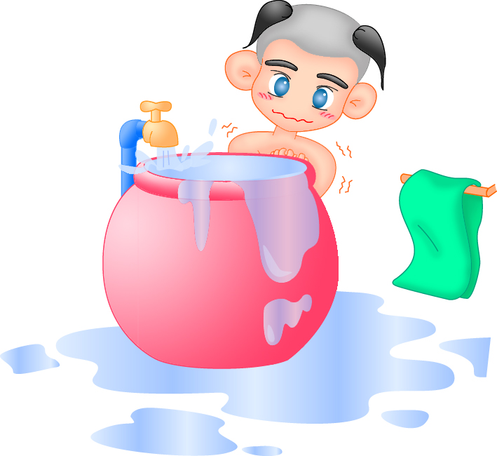
STOP
Energy and Water Privatization

Labour Union of Metropolitan Waterworks Authority

